**A Parents’ Guide to Mastery in Maths**

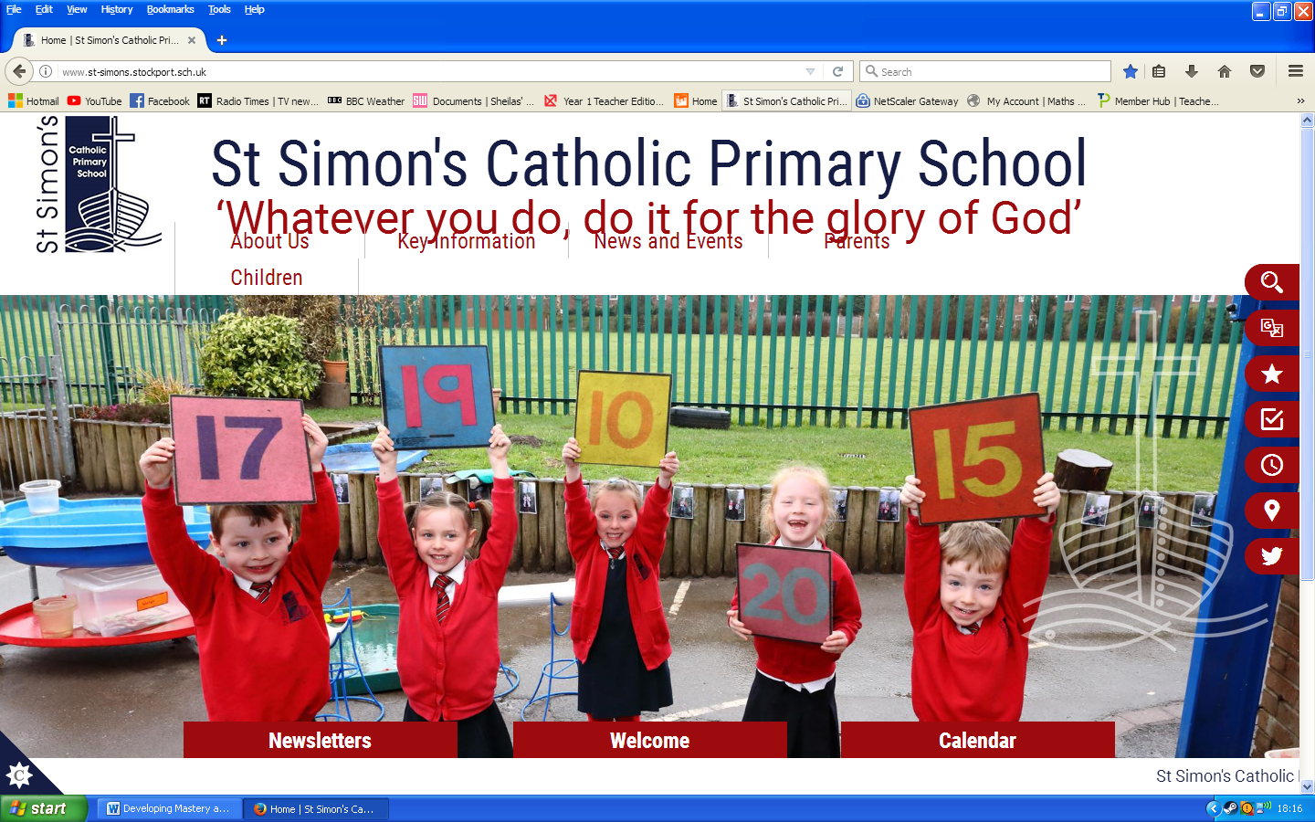

**Mastery in Maths**

The National Curriculum 2014 aims to ensure that all pupils:

* become fluent in the fundamentals of mathematics, including **varied and frequent practice** with increasingly complex problems over time, so that pupils develop conceptual understanding and the ability to recall and **apply knowledge** rapidly and accurately.

* **reason** mathematically by following a line of enquiry, conjecturing relationships and generalisations, and developing an argument, justification or proof using mathematical language.

*can solve problems by **applying their mathematics to a variety of routine and non-routine problems** with increasing sophistication, including breaking down problems into a series of simpler steps and persevering in seeking solutions.

**What is Mastery?**

**What does it mean to *master* something?**

‘I know how to do it’

‘I can do it without thinking (e.g. driving a car)’

‘I’m really good at it (e.g. painting a room/picture)’

**What does it mean to *master* mathematics?**

It’s more than the above...

It is:

* Achievable for all.
* The ability to build on something that has already been sufficiently mastered.
* **Deep** and sustained learning
* The ability to reason about a concept and make connections

A mathematical concept or skill has been *mastered* when a child can show it in multiple ways, using the mathematical language to explain their ideas, and can independently apply the concept to new problems in unfamiliar situations.

Mastery is a journey and long-term goal, achieved through exploration, clarification, practice and application over time. At each stage of learning, children should be able to demonstrate a deep, conceptual understanding of the topic and be able to build on this over time.



**Teaching for Mastery**

Teaching for Mastery involves:

* High expectations for all children
* Fewer topics covered in greater depth over a longer time
* Number sense and place value coming first
* Problem solving is central

(ensures children understand why it works so that children understand what they are doing rather than just learning to repeat routines without grasping what is happening)

* Challenge being provided through greater depth, rather than acceleration of content

**What is depth?**

**CPA Approach**

***Concrete***– children have the opportunity to use concrete objects and manipulate them to help them understand and explain what they are doing.

***Pictorial***– children then build on this concrete approach by using pictorial representations, which can then be used to reason and solve problems.

***Abstract***– with the foundations firmly laid, children can move to an abstract approach using numbers and key concepts with confidence.

**E.g.**

**Partitioning**

becomes…

This develops into…

**1**

**5**

**5**

**4**

**2**

**3**

Which develops further into…

**6**

**12**

**4**

**2**

**7**

**Building on prior knowledge**

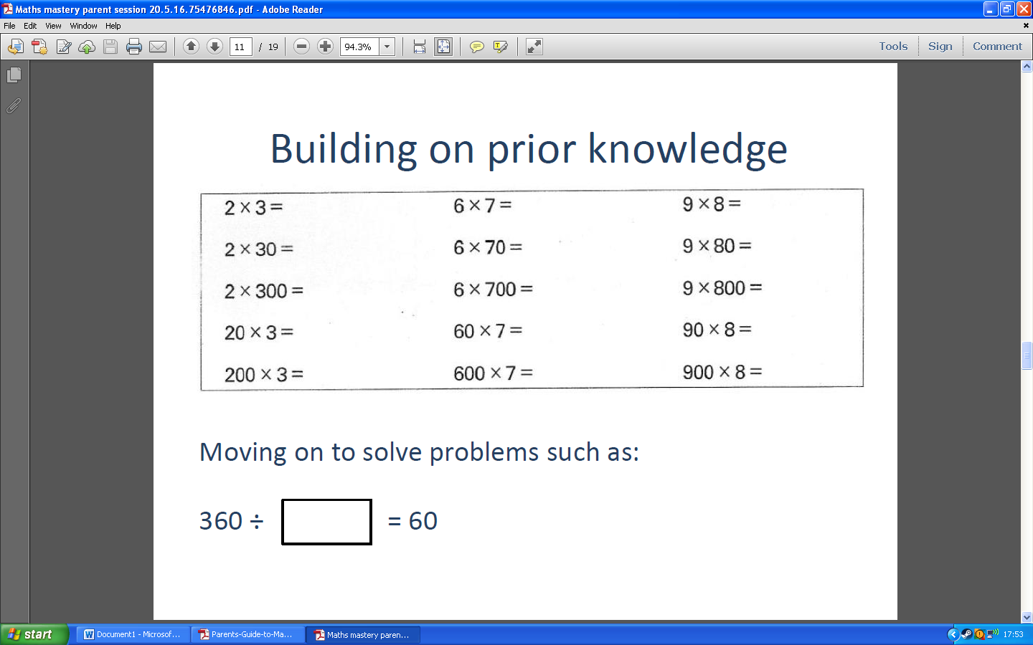

**Moving on to solving problems like:**

**420 ÷ = 60**

**Fluency**

* Quick recall of facts and procedures
* The flexibility and fluidity to move between different contexts and representations of mathematics.
* The ability to recognise relationships and make connections in mathematics

** Children need to be able to ***apply***their fluency of facts and procedures into new contexts and representations, recognise relationships and make connections in mathematics. This should help pupils develop a deep conceptual understanding of the subject.

**Reasoning**

The way pupils speak and write about mathematics transforms their learning. Teaching for Mastery involves carefully designed questions to enable pupils to explain the maths in full sentences with the correct vocabulary. They should be able to say not just what the answer is, but ***how***they know it is correct. This is key to building mathematical language and reasoning skills.

**Teachers promote reasoning during Maths lessons, through using carefully chosen questions**

E.g.

* ______________ thinks that............... Do you agree? Explain your answer.
* Is it always, sometimes or never true that ________________? Explain your answer.
* Can you spot the mistake? Explain how you know they are wrong.
* True or false? Why?
* Spot the odd one out. Why is it?

**What does this look like?**

**Which is the odd one out in the following group**

**15 23 26**

Example answer:

- 15 is the odd one out **because** it is the only one with just one ten

- 23 is the odd one out **because** it’s the only prime number

- 26 is the odd one out **because** it’s the only even number

**The ‘because’ part is the key to developing reasoning.**

**Problem Solving**

Mathematical problem solving is at the heart of the Mastery approach. Pupils apply their skills of fluency to solve complex problems and real-life situations.

Teachers will ensure fluency skills are secure and then facilitate deeper learning by using reasoning and problem solving. For example, if the learning intention is to multiply and divide whole numbers by 10, 100 and 1000 (Year 5), the lesson may have the format as shown:

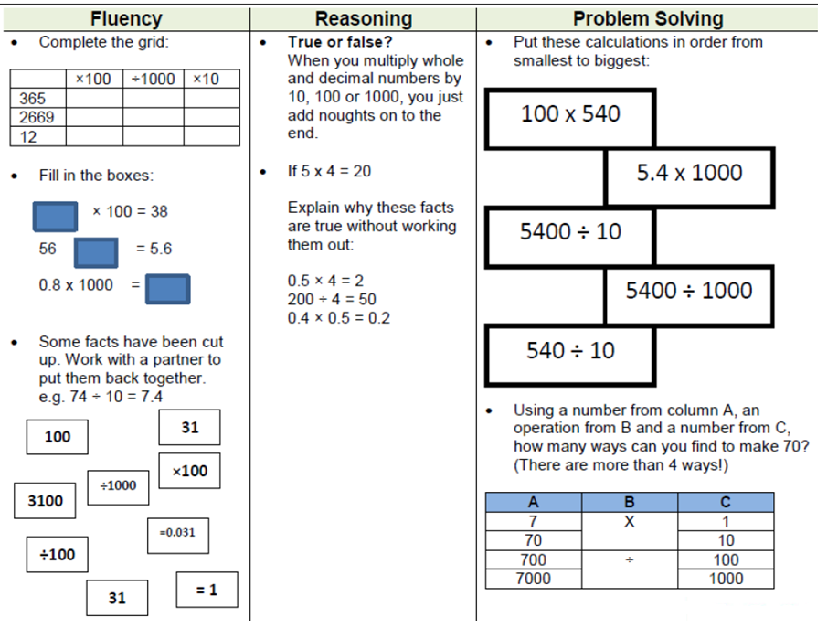

**Growth Mindset & Mastery**

Growth Mindset is very closely linked with Mastery and fosters:

* a belief that effort creates success.
* a belief that skill and ability can be increased over time.
* a belief that mistakes are viewed as an opportunity to learn and develop.
* a belief that it builds resilience – don’t give up easily.
* a belief that we should think about ***how*** we learn, not just what.

**How can you help your child at home?**

Maths learning can take place anywhere! Maths is all around us, so look for opportunities for you to do some problem solving together, making connections between what your child is learning at school and the world around them.

**Follow a recipe:** work together to find the quantities needed, ask your child to weigh the ingredients, discuss how you would halve or double the recipe, which could lead to a discussion on ratio of ingredients.

**Talk about the weather forecast:** is the temperature today higher or lower than yesterday’s? What do the numbers mean?

**Shopping:** talk about the cost of items and how the cost changes if you buy two items instead of one. Let your child count out the coins when paying and discuss the change you get back. Coins can be used to explore addition, subtraction, multiplication and division.

**Planning an outing:** discuss how long it takes to get to the park and work out what time you need to leave the house to reach there at a certain time. Encourage your child to look for different shapes you might see when you get there.

**Talk and think like a mathematician**

Maths language often uses common words in a new way. For example: ‘table’, ‘right’, ‘difference’ or ‘product’.

* Always encourage your child to ***explain how*** they have gone about solving a problem and work with them to test, prove, explain, reflect and spot patterns.
* Questioning and prompts are powerful tools to boost your child’s mathematical thinking; questions such as:

What do you think..?

Why?

What will happen if..?

What do you notice about..?

Can you see a pattern between..?

What if we try...?

* Communicating and discussing Maths problems (in a way that others can understand) demonstrates depth of understanding – another fundamental aspect of mastering mathematics.